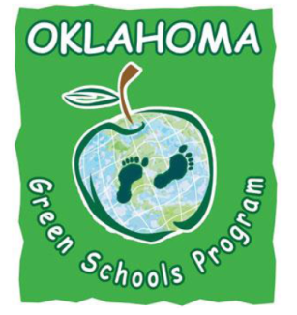
Oklahoma Green Schools
Oklahoma Recycling Resources

- DEQ Recycling Resources
http://www.deq.state.ok.us/recycle/index.htm

- Oklahoma Recycling Association
www.recycleok.org

- OKC Goodwill Recycling
http://okgoodwill.org/about-goodwill/environmental-commitment.html
Contact Bob Carman for questions bcarman@okgoodwill.org or 405-219-4171

- Republic Services (Recycle Hauling Service covers much of OK) works with schools http://www.republicservices.com
Contact: Carrie Miller at 405-990-0939 or cmiller7@republicservices.com

- American Waste Control “Mr. Murph” Tulsa – Single Stream Recycling
http://feedmrmurph.com/

- Harley Hollan (Recycling Hauling Service – Tulsa) works with schools
http://www.317-7777.com

- Natural Evolution – Electronic Recycling Tulsa
http://naturalevolution.com/ If you are not in the Tulsa area, they could probably help you find someone near you.

