[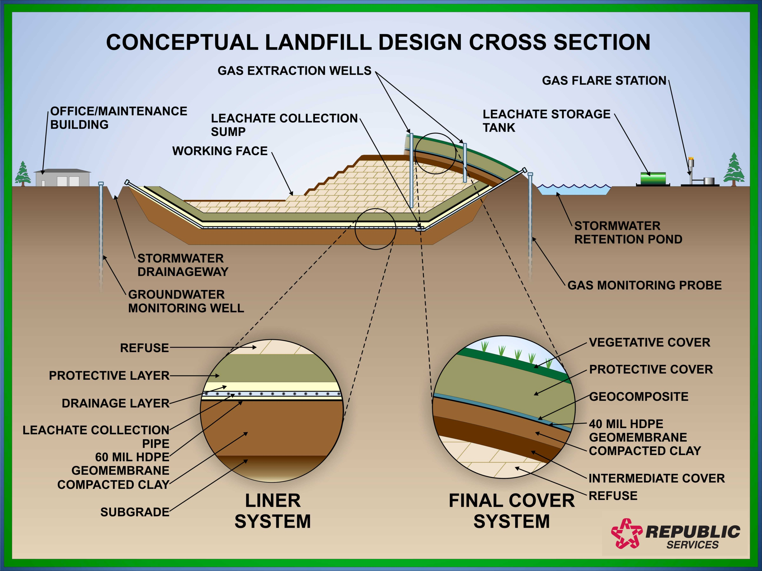](http://www.google.com/url?sa=i&rct=j&q=&esrc=s&frm=1&source=images&cd=&cad=rja&uact=8&docid=EtsSCgzpfApxMM&tbnid=t5rMi0DzJS0fzM:&ved=0CAUQjRw&url=http%3A%2F%2Fwww.republicservices.com%2Fcorporate%2Fenvironmenteducation%2Flandfill-engineering.aspx&ei=7ojOU92HKYqayAStpoHoDg&bvm=bv.71198958,d.aWw&psig=AFQjCNFwTzeZCtu7ijJ1tECwoCE-wsGilw&ust=1406130792026380)